NUCLEAR MYTHOLOGY
A.MICHEL
Groupe Esperluète
Rue pierre du diable, 66 - 5100 Namur - Belgium
am462568@scarlet.be

ABSTRACT
Scientists who worked on Manhattan project criticality tests named them “Dragon Experiments”: they were “tickling the tail of the dragon”. This fascination for mythic animals went on as reactors were named Dragon (Winfrith) or Phenix (Marcoule), a German waste treatment installation was called Fafnir, a famous dragon, and Melusine was the first reactor on the Grenoble site.
A phoenix was a logical choice for a breeder reactor, a mythical animal that regenerates again and again from its ashes. But this image was not strong enough to avoid the scares generated by the presence of plutonium together with sodium. With plutonium, we somehow missed our chance: as we all know, it was named from the planet Pluto. It could have been a good choice because Pluto was the god of all natural ground resources, be it minerals or plants. But it was also associated with infernal deeper forces. Thus a US politician once said: If there ever was an element that can be associated with hell, it is plutonium.
But dragons? It is a positive symbol in China, with multiple aspects, e.g., the year of the dragon is favourable for large projects. In Europe, it is a dangerous beast in most legendary tales, symbol of bad things that glorious saints must kill, as George or Michael did. Do Greenpeace activists dream that they follow their example when they fight nuclear developments? Always prompt to use strong images, they carried along rivers and streets, a Nessie type monster called MOX during their demonstrations against plutonium recycling. Ukrainian children after the Chernobyl accident have drawn devouring dragons, but for others, dragons are often friendly in their children’s books. I like most L’histoire d’un gentil dragon rouge by Max Velthuijs. The terrible dragon is tamed by an intelligent scientist and thus it blows its powerful flames into a boiler, producing heat and electricity for the whole town. Everybody thus loves the beast.
We have to find such symbols to familiarise nuclear activities for European populations. Could we “launch” Nukie, a friendly dragon, as a mascot for our activities?

- Naming fissile materials

Sometimes events that are not at all related to your subject have a long term influence on its development. It was the case when Klaproth discovered uranium in 1789. Planets have all been named after ancient Roman gods, themselves inherited from Greece. At the time Klaproth discovered his new substance, the British astronomer Herschel, born in Hannover, had recently observed a new planet. But it is J.E. Bode, director of the Berlin observatory in those days, publisher of an Astronomisch Jahrbuch every year, who chose the name. After Saturn, identified with the Greek god Cronos, there was some logic to choose his father Ouranos, that can be written Uranus in German and was taken as such in other languages. Klaproth, a great admirer of this astronomical discovery, decided to name the metallic substance he found after the planet, thus uranium. But Ouranos is not really a nice god. Son of Gaia, he personifies the Sky, apparently considered as a source of fertility. But at the same time, he had dozens of terrible children with Gaia, among them Titans and Cyclops. She finally was bored of being so frequently “covered” and asked one of the Titans, her son Cronos, to castrate his father. Although we could plead that uranium is the son of Gaia and thus should be considered a nice material, if we insist on mythological aspect these sinister family stories might become better known! Uranium minerals were appreciated by collectors because they glowed in the dark but it is only more than a century later that the fissile properties of uranium were discovered.

Another naturally fissile material, thorium, also received its name from a god, but a Germano-Scandinavian one. It was J.J. Berzelius who identified this material in 1829. He chose to name it thorium after the god Thor, again a terrible one, travelling around the world in a chariot pulled by two stinking billy goats, master of lightning, symbol of violent strength but also of fertility and the protector of humans. Again we can think of him with mixed feelings.

At Berkeley Radiation Laboratory, when a team of scientists among which Mac Millan and Seaborg, discovered other fissile materials, they continued to name some after the planets: neptunium and plutonium. Seaborg and Wahl, his assistant, identified element 94 on February 23, 1941; they created them using the 60-inch cyclotron and an uranyl nitrate hexahydrate target .The team discussed names (1) : ultinium, extremium, pandemonium, but they decided to continue the order of planets and the last one available was Pluto, thus plutonium and they choose to abbreviate it Pu and not Pl.

This choice was probably not the best one if we consider its impact on the public image: although the god Ploutos or Pluto means the rich, and is associated with all the resources that the ground can provide, it is its connection with the Greek god Hades and infernal forces that people remember. A US senator once said that if there ever was a material that can be associated with hell, it is plutonium. We could just as well say that the name is perfect for a material that could provide wealth and energy for thousands of years.

But it seems that we are faced with the same attitude that the media have with news: good news is no news. It is not the virtues of the gods that gave their names to our fissile materials and especially for plutonium that are remembered, it is their tragic fate that is put forward.

- From alchemy to the original sin

The discovery of radioactivity has a lot of similarities in people’s imagination with the work of alchemists. The scientists themselves realised that. This is how Weart describes it (2):
Rutherford and Soddy found, for example, that radioactive thorium, atom by atom, was gradually turning itself into radium. At the moment he realised this, Soddy recalled, “I was overwhelmed with something greater than joy – I cannot very well express it – a kind of exaltation.” He blurted out, “Rutherford, this is transmutation!” “For Mike’s sake, Soddy” his companion shot back, “don’t call it transmutation. They will have our heads off as alchemists”. But the next moment, Rutherford was waltzing around the laboratory, booming out “Onward Christian Soldiers”. Already at the instant, the new science was born, it could stir strong emotions.
This was the discovery of natural radioactivity ; later on, Pierre and Marie Curie isolated a number of naturally occurring radioactive elements. Their daughter Irene and her husband Frederic Joliot really realised the dreams of the alchemists when they obtained radioactive nitrogen from boron. As we mentioned above, Seaborg and his team could generate a nearly non existent material, plutonium, using Lawrence’s cyclotron and the appropriate target. Such actions stimulate the imagination of artists, novelists and the film industry. A typical example is Mohlitz’s engraving La découverte du plutonium : it looks as if a solitary Seaborg has worked in a fantastic environment, surrounded by mysterious phials and all sorts of skeletons. Skeletons have been connected with radioactivity since the beginnings of radiography. But they were present also early in the arts as in Melies’ film Les rayons Rôntgen, where a man walks behind the machine screen and his skeleton walks on alone.
But very soon what impressed their imagination the most was the power that might be released. Thus famous stories were published, telling how ambitious men supported by mad or greedy scientists would dominate or destroy the world with some sort of scientific devices. From Anatole France L’île des pingouins (1908) and H.G Wells The world set free (1914) to J.B Priestley The Doomsday men (1938), the stories are numerous. Wells dreamed that the use of an atomic bomb – he is the first to have used this word – would enforce a pacific world. But already in 1921 he wrote: The dream of “The World set Free”, a dream of highly educated and highly favoured leading and ruling men, voluntarily setting themselves to the task of reshaping the world, has thus far remained a dream.(3) Thus Apocalypse might result from the ambition of Doomsday men.
And indeed, such a major destruction had never been done before by a single instrument, and it was the first widely known result of atomic discoveries. Ending WWII, the three apocalyptic explosions impressed the world population forever. This “original sin” would remain in most people’s mind as a mark of infamy on any nuclear research. In the very early morning in Nevada’s desert on July 16, 1945, the scientists themselves were deeply moved when they observed Trinity’s explosion. Oppenheimer expressed his feelings with reminiscences of an epic saga from India: If the radiance of a thousand suns were to burst into the sky, that would be like the splendour of the Mighty One, but he also felt: I am become Death, the shatterer of worlds. Carson Mark, one of the researchers who had participated in the theoretical calculations, wondered if the “explosion sphere” would ever stop growing ... General Farrell thought (4) that it was a blasphemy to manipulate forces until then left to the Mighty One. Religious and mythical feelings rush back in the presence of such a monstrous phenomenon.

- Nuclear installations, gods and dragons
During the Manhattan project, the first attempts in Los Alamos to create a temporarily critical mass of fissile materials – be it with slugs of uranium or semi-spheres of plutonium – were called by the scientists “tickling the tail of the dragon”. The dragon was dangerous and during those years, it killed two scientists.

But it seems that nevertheless, scientists loved legendary animals and mythical gods, especially in Europe. The French CEA gave their names to many of its nuclear installations. Some choices had obvious origins like Siloe, a pool type research reactor: Siloe was a bathing pool in Jerusalem at the time of Jesus. But why did they decide to name another Osiris, a god that reigns over the dead? And a copy of this reactor, thus named Osirak, was sold and built for the Iraqis. Israël hated it so much that they bombed it. Why Melusine, in 1958, the first of its pool type reactors, a fairy with a snail or a fish tail (the legend is not clear on that subject ...)?

After a series of musical choices for the reactors connected with the fast breeder programme – Harmonie, Masurca, Rapsodie – they turned again to the great myths for their prototype power plant: Phenix. It had its logic as this animal comes back to life from its ashes. The Phenix reactor had its enemies but its overgrown descendant Superphenix provoked furious opposition leading to memorable battles.

The French were not alone in selecting such names: in Belgium, the underground galleries in the Boom clay, under the nuclear research centre in Mol were named Hades. A certain logic again for an underground test lab that would provide the information to define and guarantee the feasibility of geological storage to keep indefinitely highly radioactive wastes which are in peoples’ minds dangerous whatever the packaging. Extending this research under European auspices, they named the interest group Euridice. Great! She never came out of the Inferno, even with the help of her lover Orpheus. This name must be taken as a guarantee that those wastes will stay underground for ever !

Other countries loved dragons; I do too ... A German company named a waste treatment installation Fafnir, after the famous dragon that Siegfried had to fight. In England in 1962, the UKAEA started a high temperature gas cooled reactor in Winfrith, simply called Dragon. It was run as an OECD/NEA project, burning coated particles. Even the Nuclear Decommissioning Authority loves to play with such symbols: when this reactor was dismantled and virtually empty, NDA titled its Stakeholders newsletter: “Winfrith’s DRAGON loses its fire.”

No wonder that nuclear opponents or fiction writers represent nuclear activities as dangerous dragons. In one of the first James Bond film, Dr No lives on an island that is supposedly inhabited by a dragon which in reality is a nuclear reactor. Nearly 50 years later, Professor David Phillips, president of the British Royal Society of Chemistry blamed the film for casting a long-lasting shadow over the image of nuclear (...) nuclear technology being presented as a “barely controllable force for evil” (5).

Greenpeace designed a very aggressive Nessie type dragon to represent MOX. They carried it along the river near the Belgonucleaire MOX fuel plant in 1992 during demonstrations against the extension of the plant. They later obtained cancellation of this project (using legal arguments, not the dragon!). They used it again in the streets of Huy when they tried to prevent loading of MOX fuel into the Tihange reactor. They did not succeed. When in Saskatchewan (Canada) people resisted a big-corporate plan to mine uranium, they claimed: “Nuclear dragons attack”.

It is a dragon made of US Pershing and Russian SS20 missiles that St George kills on New York’s UN grounds, a sculpture named “Good Defeats Evil”, created by the Russian artist Zurab Tsereteli. Novels abound with nuclear dragons; Nuclear dragon tells the story of a fusion reactor explosion, Legacy of dragons is about a supposedly lost World War II atomic bomb, The tail of the dragon narrates a CIA conspiracy against its own government. A recent puppet show in the Cité des Sciences in Paris and in other places, represented nuclear power as a dragon that must be slaughtered. Non-fiction titles also use the dragon symbol. Slaying the nuclear dragon is about nuclear disarmament dynamics in the XXIst century. Feeding the nuclear dragon was the title in 1995 of a description of developments of the nuclear industry in China by the Canadian campaign against nuclear development at a time when AECL signed a Memorandum of Understanding with China National Nuclear Corporation. This year, two Chinese authors titled their paper on the prospect and potential of cross-Strait cooperation on nuclear security, Taming the dragon. (6)

- Taming the dragon?

This is also the question I ask in the book I am preparing, probably published this winter, Dompter le dragon nucléaire ? Réalités, fantasmes et émotions dans la culture populaire. I insist on the importance of dreams and images. If representing nuclear energy as a dragon seems so evident to so many people, why shouldn’t we follow and make use of this symbol? After all, this legendary monster appears as a primordial force, coexistent with the emergence of the world (7). It was scary in the old days when numerous saints and heroes had to kill them. By the way, does Greenpeace and its friends feel like being St George or St Michael when they fight nuclear activities? But today, dragons are mostly part of folklore activities. In children books they are seldom scary and always end as the best friend of the children, sometimes even as their pet animal.

After all, dragons have some positive analogies with nuclear power plants: as already mentioned dragons symbolise primal forces as nuclear chain reactions are. They usually stay underground, in deep caves. Initially in Europe we did install our nuclear plants deep in the hills, for example Chooz (in the north of France, nearly in Belgium) where nobody objected to plant A’s presence – which was not the case for the big ones later outside. Possibly we should at some time go back to the “âge des cavernes” to satisfy people’s anxieties and to resist terrorists and planes crashes. If he wants to work with a dragon, the tamer must learn its behaviour and should use patience and not violence. He should never turn his back to the animal. It is the same with a nuclear plant, you have to pay attention at all times.

In Max Velthuijs Le gentil dragon rouge, the enormous animal terrifies the town. He burns the nearby forest, resists the action of the fire brigade, carries away the cage in which they try to trap him. Nothing works to tame it until a learned professor has the good idea to build a steam engine in which the gentle dragon can blow his flames. It provides heat and electricity for the whole town and everyone is happy and thankful. Isn’t that the story we would like to tell about our activities? Would a nice Nukie, yet to be drawn, not be a good symbol of nuclear energy? Is it too naïve a suggestion? Let’s try …

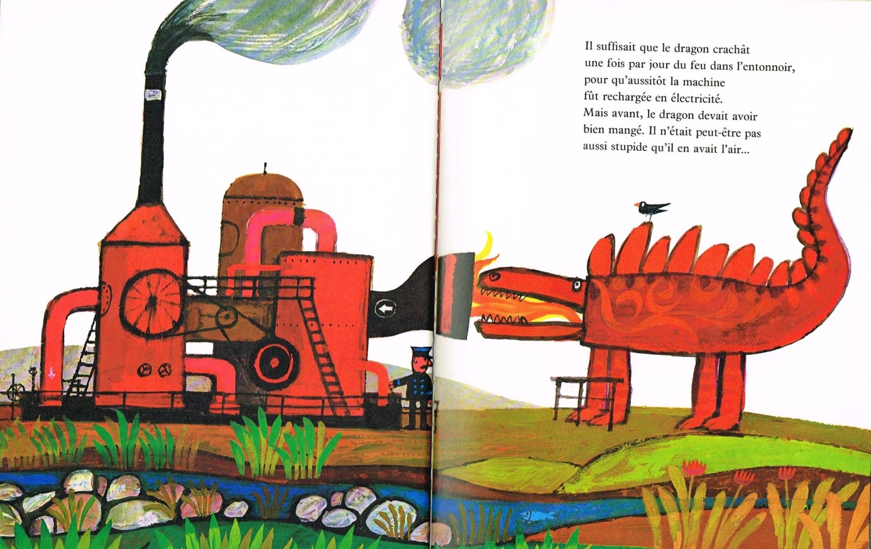
copyright Stichting Max Velthuijs – The Hague- The Netherlands

- References

- According to James Mahaffey in Atomic Awareness – Pegasus Books - NY 2009
- Spencer R. Weart – Nuclear Fear - Harvard University Press – Cambridge USA 1988
- H.G Welles in the preface of the 1921 edition of The World Set Free
- R. Jungk –Heller als tausend Sonnen – Alfred Scherz Verlag – 1956
- Sean Coughlan – James Bond villains blamed for nuclear’s bad image – BBC news – 12 January 2012
- Ying-Feng Chen & Yungnane Yang – in Journal of Asian Policy, Volume 5, Issue 2, 2012
- Z. Gourarier & al – Dragons – Editions Serpennoises – Metz 2005
- Max Velthuijs – Le gentil dragon rouge- Fernand Nathan – Paris 1974

